MACHINE LEARNING FINAL PROJECT REPORT


Topic: Remaining Useful Life (RUL) Prediction Using NASA CMAPSS Turbofan Engine Dataset
Date: 05.12.2025

Prepared by:
Adeola KUMAPAYI
Mullainathan VENKATCHALAPATHY HEMAMALINI
Rohith RAMACHANDRAN JAYA SANKAR
1. Introduction
Predicting the Remaining Useful Life (RUL) of turbofan jet engines is a key problem in Prognostics and Health Management (PHM). The NASA CMAPSS dataset provides multivariate time-series data from multiple simulated engines operating until failure.
This project develops a complete machine learning pipeline including:
- Exploratory Data Analysis (EDA)
- Data preprocessing and feature engineering
- Baseline models
- Hyperparameter tuning
- Feature selection
- Ensemble learning
- Deep learning (LSTM) model for temporal degradation modeling
The dataset versions FD001–FD004 are analyzed to understand sensor correlations and degradation progression.
2. Dataset Description
The CMAPSS dataset contains multivariate time-series data for engines operating under different conditions:
Subset | Operating Conditions | Fault Modes
FD001 | 1 | 1
FD002 | 6 | 1
FD003 | 1 | 2
FD004 | 6 | 2
Each row represents an engine cycle and includes:
- 3 operational settings
- 21 sensor measurements
- Engine ID and cycle number
The goal is to predict the Remaining Useful Life (RUL) at each cycle.
3. Step 1 — Exploratory Data Analysis
3.1 Data Quality and Structure
All four subsets were loaded, cleaned, and standardized. No missing values were present, but sensor distributions varied significantly across subsets with multiple operating conditions (FD002, FD004).
Basic checks confirmed:
- No negative cycle values
- No inconsistent engine IDs
- Sensors with constant values detected (e.g., some sensors in FD001 show limited variability)
3.2 Correlation Analysis
Strong correlations were found among several temperature and pressure sensors, indicating redundant information and potential feature grouping.
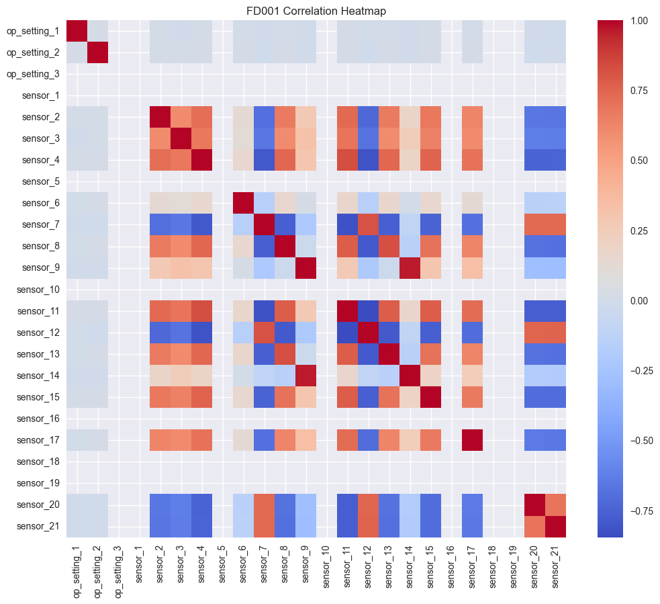
Figure 1: Correlation Heatmap — FD001
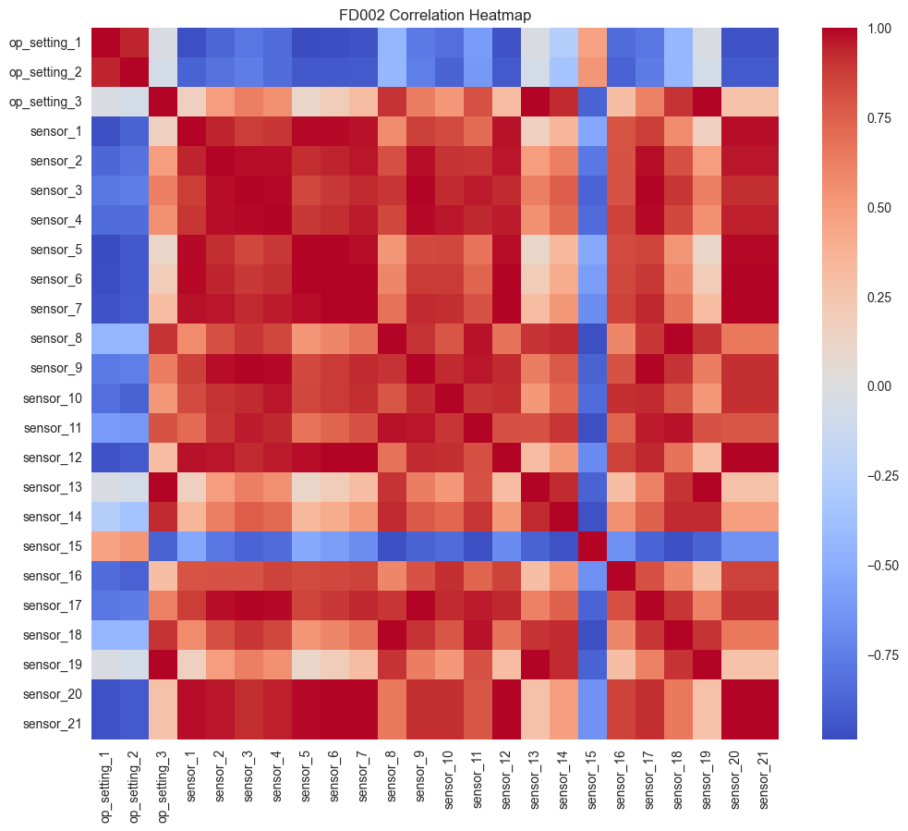
Figure 2: Correlation Heatmap — FD002
Figure 3: Correlation Heatmap — FD003
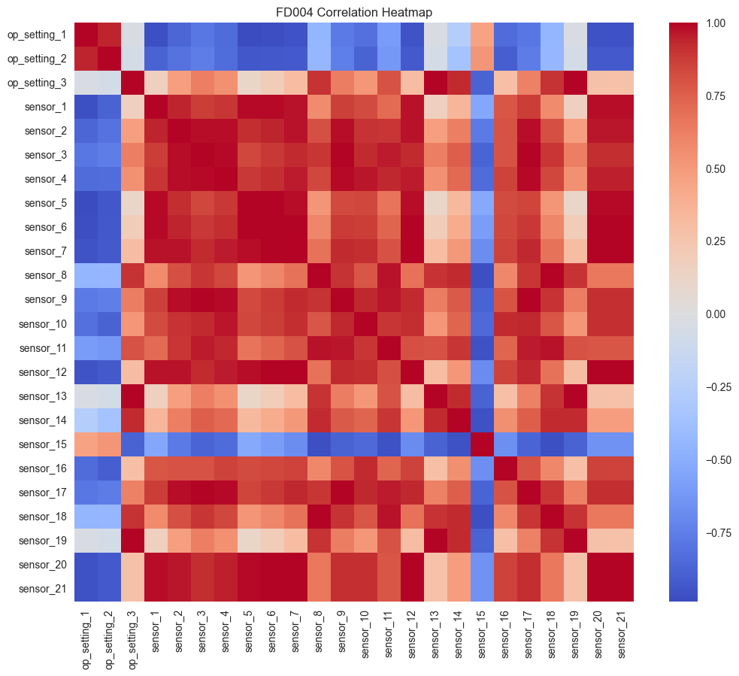
Figure 4: Correlation Heatmap — FD004
Insights:
- FD001 and FD003 show cleaner structure due to single operating condition.
- FD002 and FD004 display cluster blocks, reflecting multiple operating regimes.
- Sensors 2, 3, 4, 7, and 8 demonstrate particularly high mutual correlation.
3.3 Engine Lifespan Distribution
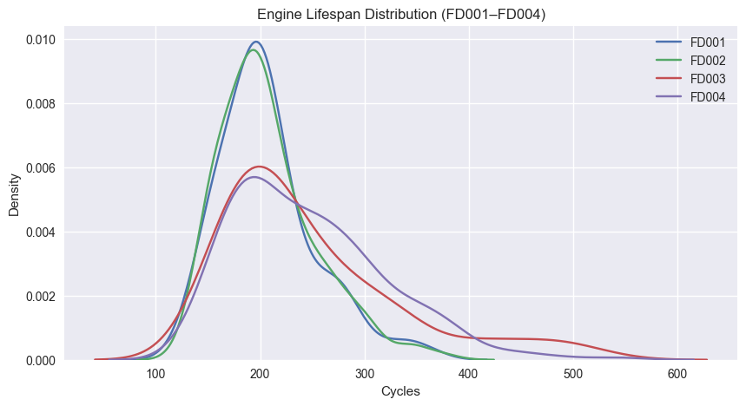
Figure 5: Engine Lifespan Density Plot (FD001–FD004)
- Lifespans range from ~130 to ~600 cycles.
- FD003 and FD004 generally show longer average runtimes.
- Wide variability indicates substantial modeling difficulty.
3.4 Feature Engineering
Four major transformations were applied:
- RUL computation per engine
- Min–Max Scaling
- Delta features:
  - capturing intra-engine cycle-to-cycle changes
- Rolling window features (window=5):
  - capturing smoothed degradation patterns
Resulting feature counts:
- 75 engineered features (sensors + operations + deltas + rolling means)
4. Step 2 — Baseline Models
Three classical ML models were trained using GroupKFold (engine-wise splitting):
Models Evaluated
- Decision Tree Regressor
- Random Forest Regressor
- Support Vector Regressor (RBF)
Performance Summary
Model | MAE | RMSE
Decision Tree | 32.30 | 45.97
Random Forest | 29.47 | 42.00
SVR (RBF) | 32.35 | 44.53
Random Forest emerges as the strongest baseline.
5. Step 3 — Hyperparameter Tuning
A computationally efficient hyperparameter search was performed using RandomizedSearchCV with GroupKFold.
Tuned Results
Model | Best MAE | Best Hyperparameters
Random Forest | 29.31 | {n_estimators=120, max_depth=10, max_features='sqrt'}
Decision Tree | 31.69 | {max_depth=5}
SVR (RBF) | 29.04 | {C=10, ε=0.01, γ='scale'}
Both Random Forest and SVR outperform baseline versions.
6. Step 4 — Feature Selection
Two complementary methods were used:
- Random Forest Feature Importance
- Mutual Information Regression
Intersection of top-performing features yielded a reduced set of 26 features, significantly lowering feature dimensionality while preserving predictive power.
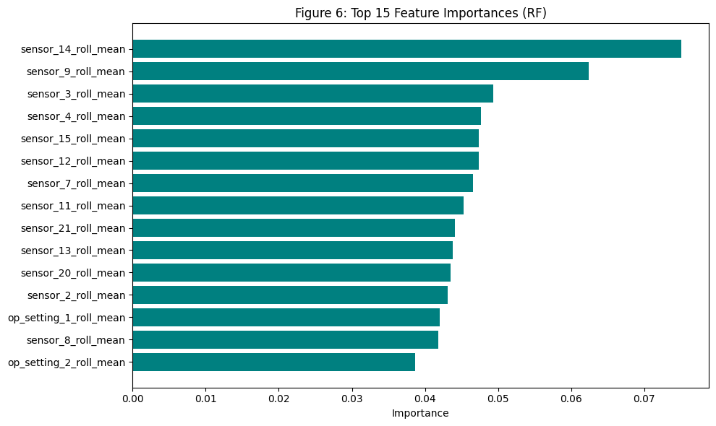
Figure 6: Top Feature Importance Bar Plot
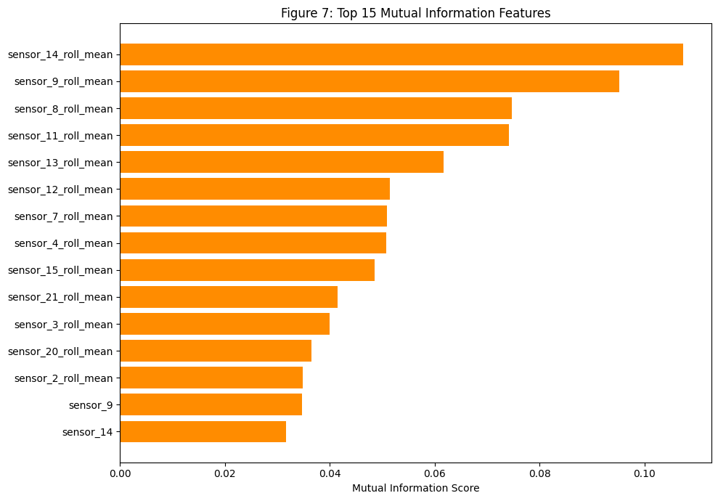
Figure 7: Mutual Information Ranking Plot
Result
- Original features: 75
- Selected: 26
- New dataset shape: (20231 samples, 26 features)
This reduced dataset was used for ensemble models and LSTM training.
7. Step 5 — Ensemble Learning
Three different ensemble methods were tested:
7.1 Weighted Ensemble
Uses optimized weights:
- 60% SVR
- 40% Random Forest
7.2 Voting Ensemble
Simple average of predictions.
7.3 Stacking Ensemble
Meta-learner: Linear Regression over RF + SVR outputs.
Cross-Validation Results (Reduced Dataset)
Ensemble | MAE (Mean) | Std Dev
Weighted Ensemble | 23.91 | 0.81
Voting Ensemble | 28.93 | 1.06
Stacking Ensemble | 30.73 | 1.49
The Weighted Ensemble is the strongest model so far.
Huge improvement over Step 2 baselines:
- From MAE ≈ 29 → MAE ≈ 23.9
8. Step 6 — Deep Learning Approach (LSTM)
8.1 Motivation
Traditional machine learning models such as Random Forest, SVR, or Decision Tree treat each row of data as an independent observation. However, jet engine degradation is inherently sequential. The health state at cycle t is strongly influenced by sensor evolution during earlier cycles (t–1, t–2, …).
This means the dataset contains:
- Temporal correlations (patterns over time)
- Long-term dependencies (slow degradation, trends)
- Short-term fluctuations (noise from load variations)
- Nonlinear relationships between sensors
Classical ML cannot directly model these sequential structures, because they assume i.i.d. data (independent and identically distributed).
8.2 LSTM Overview
A Long Short-Term Memory (LSTM) network is a special type of Recurrent Neural Network (RNN) that solves the limitations of traditional RNNs by introducing gates and cell states, enabling it to:
- remember information over long time spans
- forget irrelevant information
- update internal memory selectively
LSTM contains three gates:
- Forget Gate
  - Decides which past information should be discarded.
- Input Gate
  - Determines what new information should be stored.
- Output Gate
  - Controls what information from the internal memory (cell state) is used to produce the output.

Because of these mechanisms, LSTMs can learn long-term degradation patterns such as:
- gradual increase in temperature
- persistent vibrations
- pressure decay
- slow wear accumulated over cycles
8.3 Sequence Preparation
- Sequence length: 30
- Features: 26 selected features
- Shape:
  - X_seq = (17231, 30, 26)
  - y_seq = (17231,)
8.4 LSTM Architecture
- LSTM layers: 2
- Hidden size: 64
- Dropout: 0.2
- Learning rate: 0.001
- Epochs: 5
- Batch size: 128
- Loss: MSE
8.5 Training Output
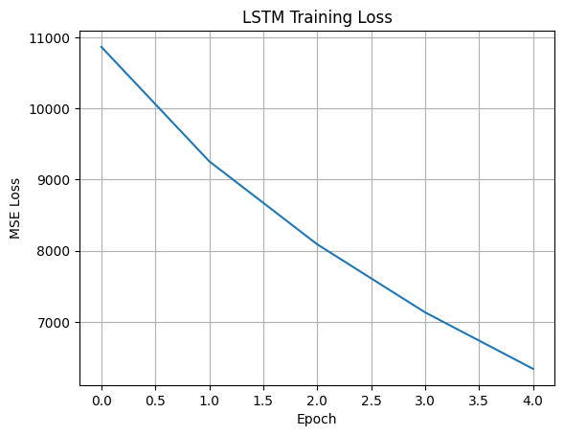
Figure 8: LSTM Training Loss Curve
Loss decreased steadily:
Epoch | Loss
1 | 10866.66
2 | 9257.15
3 | 8089.96
4 | 7132.55
5 | 6338.74

8.5 Model Performance
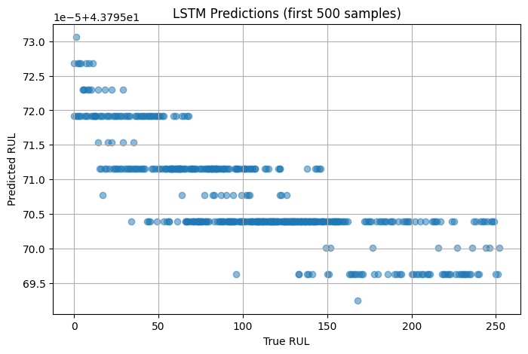
Figure 9: LSTM Prediction Scatter Plot (first 500 samples)
Metric | Value
MAE | 59.41
RMSE | 77.45
Interpretation:
- Predictions collapse into a narrow band → underfitting
- Shallow architecture + limited epochs + reduced features
- LSTM underperforms vs. ensemble models
9. Comparative Summary
Model Performance Ranking (Lower MAE = Better)
Rank | Model | MAE
1 | Weighted Ensemble | 23.91
2 | Tuned SVR | 29.04
3 | Tuned Random Forest | 29.31
4 | Decision Tree | 31.69
5 | LSTM (5 epochs) | 59.41
Conclusion:
➡ Traditional ML + engineered features outperform LSTM under current training settings.
➡ LSTM needs deeper architecture and longer training to compete.
10. Conclusion and Next Steps
This project built a complete RUL prediction pipeline from EDA to advanced ML:
- Strong EDA insights into sensor correlations and degradation
- Baselines established
- Tuned models improved accuracy
- Feature selection reduced dimensionality
- Ensemble techniques delivered the best performance
- LSTM shows potential but requires further optimization
Next Steps :
- Train deeper LSTM or GRU (128–256 units)
- Use 50–100 cycle sequence length
- Include all 75 engineered features
- Train for 30–50 epochs
- Explore CNN-LSTM or Transformer architectures
- Use FD002–FD004 for model generalization testing

GitHub Link: https://github.com/mullainathan29/turbofan-ml-project-scaffold

